2017 NEBRASKA SCIENCE OLYMPIAD HALL OF FAME INDUCTEES
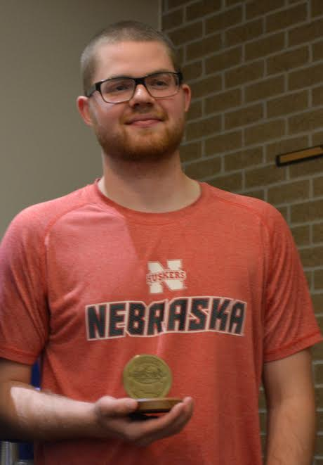
NATHAN DUFFY
Nathan competed on the Mission Middle School Science Olympiad team and the Bellevue East high school team. Over the course of his seven years of competition he won seven gold medals, one silver medal, and four bronze medals. Nathan currently attends UNL and is majoring in Horticulture. He plans to open a hydroponics business when he graduates. Nathan continued his involvement in Science Olympiad by volunteering. He has run events at the zoo tournament and the state tournament. Nathan is willing to help with whatever event needs it, even at the very last minutes, and has been invaluable helping these tournaments run successfully. He is currently assisting today with the Towers event.
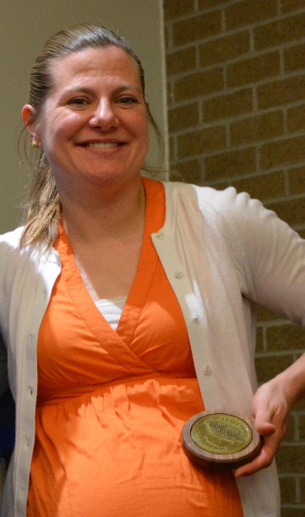

TRACY FREEOUF
Tracy Wolz Freeouf competed on the Mission Middle School team and the Bellevue East high school Science Olympiad teams. At the 2003 national tournament at The Ohio State University, Tracy and her twin brother Travis won 4th place in Boomilever. She won many medals over her seven years of competition including a 1st place in Water Strider at the state tournament and 13th in that event at the national tournament. Tracy earned a BS at UNL in Mechanical Engineering and a Masters of Engineering Management from UNL and is a Profession Engineer. Tracy continued to help Science Olympiad by returning to be the Event Supervisor for the wheeled events, such as Scrambler, Wheeled Vehicle, and Mousetrap Car, from 2005-2013 and she returned in 2015 to help with the national tournament.

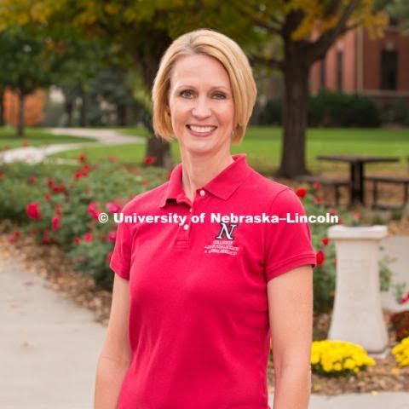

LAURA FREY
Laura was involved with the Nebraska Science Olympiad for more than 11 years. She was part of the committee to bring the yearly event to UNL's East Campus in 2006 and continued to coordinate the event every year after that. Laura was also a member of the 2015 National Science Olympiad Planning Committee, who devoted several years to coordinating the event. Laura served as UNL’s College of Agricultural Sciences and Natural Resources College Relations Director for 11 years, before joining her husband at Triumph, their Home Health Supply Business, in July 2016. We would not be enjoying the beautiful East Campus without Laura’s vision.
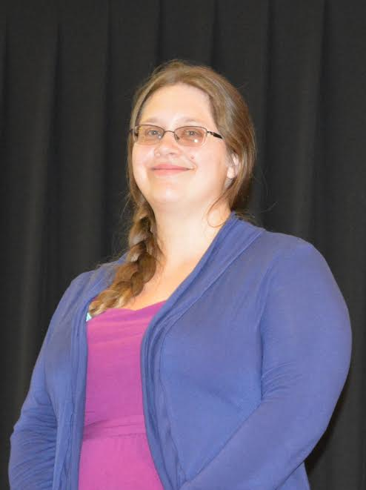

SARAH ORLEY
Sarah was on the Anderson Middle School, Millard South, and Millard West Science Olympiad teams. Sarah won three medals at the 1993 national tournament: 3rd place in Bio Process Lab, 6th place in Measurement, and 6th place in Road Rally. At the 1994 national tournament Sarah won 4th place in Bio Process Lab, 6th place in Earth Science, and a 6th place in a trial event. At the Nebraska State Tournaments, when we only gave medals to the top 3 places, Sarah won 17 medals: 6 gold medals, 6 silver medals, and 5 bronze medals. Sarah continued her education at Iowa State University majoring in Computer Engineering.

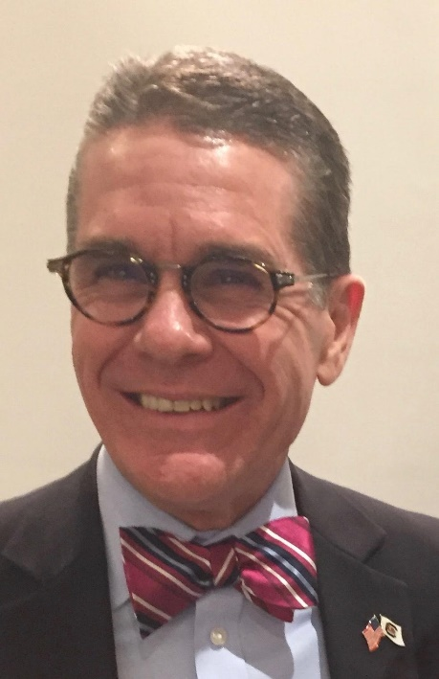

JON PEDERSEN
Jon was a UNL graduate and became the UNL Associate Dean for Research at the UNL College of Education and Human Resources. He was the Event Supervisor Coordinator for eight years for Nebraska Science Olympiad. In 2015, he was the tournament director for the Science Olympiad National Tournament which was held at UNL and was a huge success. Jon joined the National Science Olympiad Advisory Board in 2013 and now is on the National Science Olympiad Executive Board helping plan the events and rules that will shape future years of Science Olympiad. Jon currently is the Dean of University of South Carolina University College of Education.

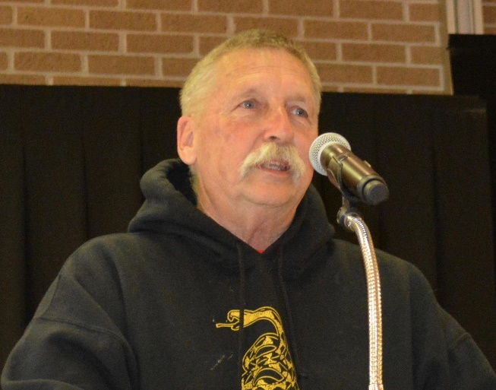
JAKE WINEMILLER
Jake first was the Science Olympiad coach for Culler middle school the first year of Science Olympiad in Nebraska (30 years ago!). Since that time, he has coached Lincoln Pound MS to two state titles and Lincoln Southeast HS to eight state titles. He created a new event for Science Olympiad- Bottle Rockets! Bottle Rockets in many different versions is a frequent Science Olympiad event and Jake ran it at our 30th anniversary tournament and he pioneered a new version of Bottle Rockets, Indoor Bottle Rockets, which he tested out at the Nebraska tournament and will take as a trial event at the national tournament in Dayton. He was the Bottle Rocket Event Supervisor at the UNL national tournament. Jake has run invitational tournaments, helped with the Nebraska tournament, was a member of the National Technology Planning Committee. Jake has presented at the National Science Olympiad Coaches Clinic in Hammond, IN.

