Name___________________
Dry Ice Labs
1.Triple Point of Dry Ice
Materials: Safety glasses, dry ice, plastic pipet, plastic cup, tap water, pliers, scissors
Procedure:
- Obtain needed materials.
- Place 2 or 3 small pieces of dry ice on the table and observe them until they completely sublime. Record your observations.
- Fill the plastic cup ½ full with tap water.
- Cut off the stem of the pipet at an angle leaving 1 ½ inches.
- Slide 8-10 small pieces of dry ice down the pipet stem and into the bulb.
- Using pliers, fold the opening of the stem and clamp it securely shut with the pliers so the no gas can escape.
- Immediately lower the pipet into the cup of water so the bulb is submerged. Record your observations.
- After 10-15 seconds, loosen the grip on the pliers and observe the bulb. Record your observations.
- Re-tighten the grip on the pliers and record your observations.
- Repeat steps 6 and 7 as many times as possible. Record your observations.

Observations:

Questions:
- What does sublime mean?

- What compound is dry ice?

- What is a triple point?

- Observe the phase diagram of carbon dioxide below, what is the temperature and pressure at the triple point of CO₂?

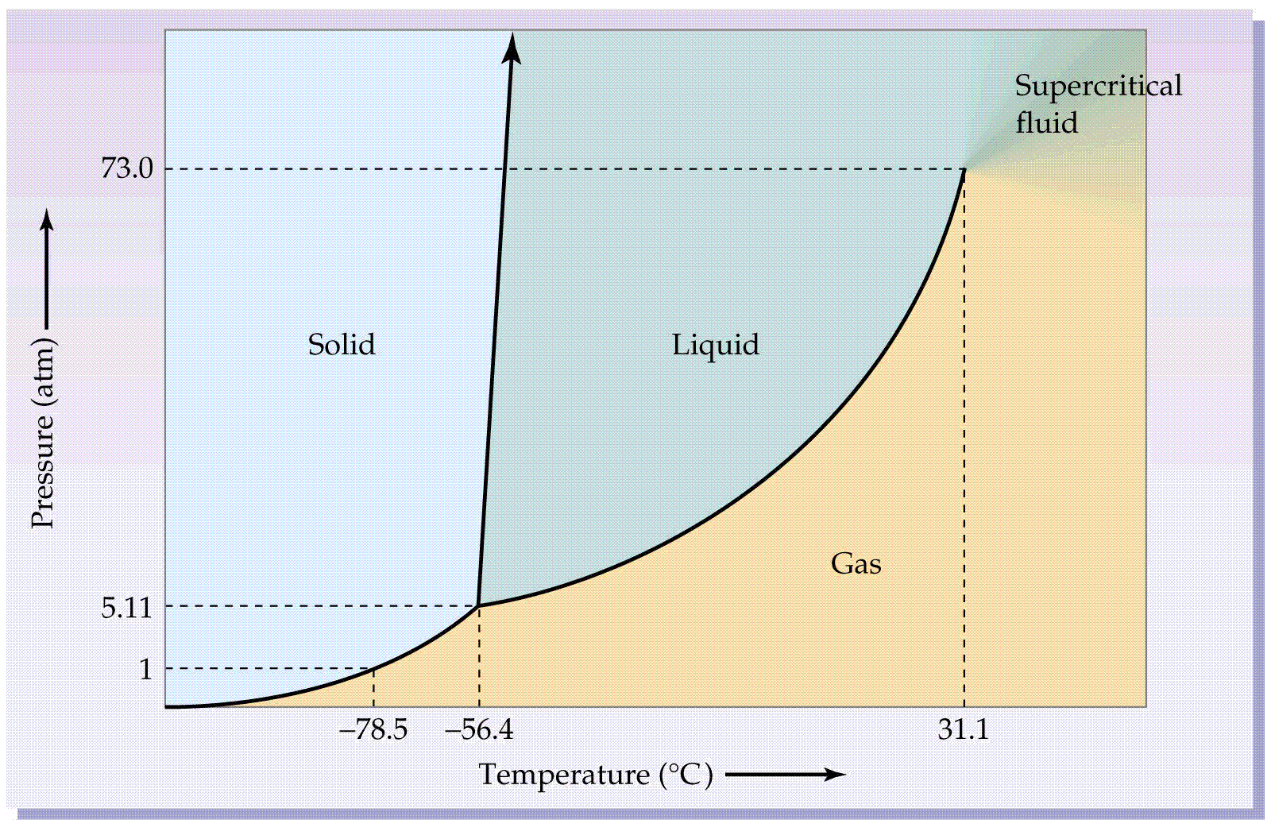
2. Dry Ice Rainbow
Materials: Goggles, Plastic Cup, Water, Dry Ice, Universal Indicator
Procedure:
- Obtain needed materials.
- Fill the cup ¾ with water, and place 1 pipette full of Universal Indicator in your cup.
- Place a chunk of dry ice (Ping pong ball sized) into your cup. Record your observations.
Observations:

Questions:
- What is an indicator used for?

- What did the changes of color indicate? What does that tell you about the dry ice?

3. Dry Ice Song and Dance
Materials: Goggles, Dry Ice, Various substances
Procedure:
- Obtain several small pieces of dry ice.
- Place them on the table and record your observations.
- Touch various substances (metal, paper, water, etc.) to the dry ice and record your observations.
Observations:

Questions:
- What causes the behavior of the dry ice when set on the table?

- What causes the noise created by the dry ice when it encounters certain substances?

4. Dry Ice and Magnesium Demo (will do together)
Materials: Goggles, Dry Ice, Magnesium metal, bunsen burner, Gloves, Tongs
Procedure:
- Obtain a small sample of magnesium and light it on fire using the Bunsen Burner.
- Place the lit Magnesium inside two pieces of dry ice. Record Observations.
Observations:

Questions:
- What was the resulting substance left inside the dry ice?

- What observations would lead you to believe the substance may not be magnesium anymore? How might you test this?

