To: Nebraska Association of Teachers of Science Conference Exhibitors and Sponsors

The 2021 NATS Fall Conference is fast approaching! We invite you to register to exhibit or be a sponsor at this year’s event. This year’s conference will be held October 7-9, 2021, at Doane University in Crete, Nebraska.

Previous NATS Fall Conferences have been attended by more than 150 science teachers, administrators, and professionals from across Nebraska. This year’s event has potential to attract a similar number of enthusiastic educators.

The exhibit area will open to conference attendees on Friday, October 8th at 7:30 AM and close at 4:00 PM. This year’s event will also include an ice cream social on Friday at 2:00 pm, hosted in the vendor exhibit hall - Perry Campus Center (see attached map).

There are several sponsorship levels available for additional company exposure. Please review the sponsorship contract carefully and let us know if you have any questions.

All exhibitors and sponsors are handled on a first come, first served basis. Space is limited for this year’s event, so don’t hesitate to return your completed forms with payment before the registration deadline, as we will sell out of space beforehand.

Completed forms and payment must be returned by September 1, 2021, to:
NATS
℅ Christine Gustafson
4851 S 187th Ave.
Omaha, NE 68135

Additional conference information, duplicate forms, and updates on exhibit space can be found at www.neacadsci.org/NATSFC

Please feel free to contact NATS/Chris Gustafson with any additional questions:
402-679-7900 (cell), cmgustafson@mpsomaha.org or natsboard14@gmail.com

Company Name: |  | Representative:

Address:

City/State/Zip:

Telephone: |  | Email:

Type of Business:

Names for Badges at Conference:

NATS does our best to accurately advertise for your company on the
Conference App and sponsor pages. Help us by filling out the following:

Booth/Company Description/Contact information:
Sales or coupons to include in description:
Company Logo to use | Please send to jenniferjones@opsd.org

Purchase Information:
Item | Quantity | Unit Cost | Amount
Table |  | $200
Electricity at Booth |  | No charge
Additional Lunch Tickets  (1 free with sponsorship) |  | $15
Sponsorship
Total
Payments Accepted: Check (make payable to NATS), Credit Card (use form below), PayPal (nebacad@unl.edu)
*processing fee will be charged on all credit card transactions

Credit Card Authorization A receipt will be emailed to you after your card is processed
Name (as it appears on card) _________________________________________________
Billing Address, City, State, Zip Code __________________________________________
Card Number _____________________________________________________________
Expiration Date ________________ CVV Code (3 digits on back of card) ______________
Invoice # __________________ Amount to be Charged* _________________(+ transaction fees)
Return this form and payment by September 1, 2021 to: NATS ℅ Christine Gustafson 4851 S 187th Ave. Omaha, NE 68135 or natsboard14@gmail.com Phone: 402-679-7900
Information for Vendors
Booth Price $200 per table
Included with Purchase One – 8 foot table, 1-2 chairs
One paid registration to NATS Fall Conference

Location: Doane University 1014 Boswell Ave, Crete, NE 68333

Display Timeline Exhibitor Set Up October 7th AFTER 3:00 PM
Exhibits Open October 8th, 7:30AM - 3:30 PM
Ice Cream Social October 8th, 2:00 - 2:30 PM
Exhibit Tear Down October 8th AFTER 3:30 PM

Electricity and Internet Electricity will be provided to your booth if you selected to have it on your contract. Wireless internet is available throughout the conference center at no additional charge. The wireless internet connection at your booth CANNOT be guaranteed.

Confirmation All vendors that successfully purchase a booth will receive a confirmation email with further instructions regarding shipping and your booth location at this year’s event.

Vendor Contact Information The contact information provided on your contract page will be made available during the conference on the event app. Please provide accurate contact information to allow for efficient communication.

Vendor Presentations If you’re interested in presenting a session, please complete the call for proposals form found at neacadsci.org/NATSFC

Vendor Passport/Scavenger Hunt In order to increase traffic at the vendor booths, a vendor passport/scavenger hunt will be promoted among conference goers. Participants will need to visit booths to get a stamp in order to be entered into a prize raffle. Vendors are welcome and encouraged to participate by donating an item for the raffle.

Silent Auction The conference will host a silent auction. Vendors are welcome and encouraged to bring items for the auction. Please contact NATS for more information.

Lunch Tickets Lunch tickets can be purchased for $15 each. Upgrade to Bronze-level sponsor for a free lunch ticket (see sponsorship page below).

Lodging Lodging for vendors is done on your own. Below is the contact information for the conference hotel:
Fairfield Inn (402) 318-7770
3015 Betten Dr, Crete, NE 68333

Cancellations and Refunds The cancellation deadline is September 1, 2021. No refunds will be provided after this date.

Vendor Sponsorship Opportunities
Level | Amount | Benefits
Platinum | - $1000+  - Silent Auction Item -AND-  - Vendor Passport Raffle Donation | Diamond Level Plus:  - Recognition at all meals  - Choice of booth location (order of selection based on order sponsorships received)  - 6 additional shares (12 total) of products/services on NATS social media* (1 per month for 1 year)  - Logo/Link on all NATS emails to members  - Up to Four Free Friday lunch tickets
Diamond | - $600  - Silent Auction Item -AND-  - Vendor Passport Raffle Donation | Gold Level Plus:  - Choice of booth location (after platinum level sponsors, order of selection based on the order sponsorships are received)  - 2 additional shares (6 total) of products/services on NATS social media* (1 every other month for 1 year)  - Logo/Link on all NATS emails to members  - Recognition at social events
Gold | - $300  - Silent Auction Item -AND-  - Vendor Passport Raffle Donation | Silver Level Plus:  - Recognition at beverage station  - Complementary booth space  - 2 additional shares (4 total) of products/services on NATS social media* (quarterly for 1 year)  - Two Free Friday lunch tickets
Silver | - $100  - Silent Auction Item -AND-  - Vendor Passport Raffle Donation | Bronze Level Plus:  - Social media and email promotion leading up to conference  - 2 shares of product/services on NATS social media* (semi-annual, good for 1 year)  - Free Friday lunch ticket
Bronze | - Silent Auction Item -AND-  - Vendor Passport Raffle Donation | - Sponsor logo will be in vendor raffle handout  - Recognition in the conference app  - Free Friday lunch ticket
*Social Media shares must be sent by sponsor to NATS. NATS will not generate advertising content for you. Failure to send content to NATS for sharing negates this benefit.

**If there is a special social event or keynote that you would like to sponsor either Thursday night or Friday, please contact us.
Perry Campus Center - Vendor Hall
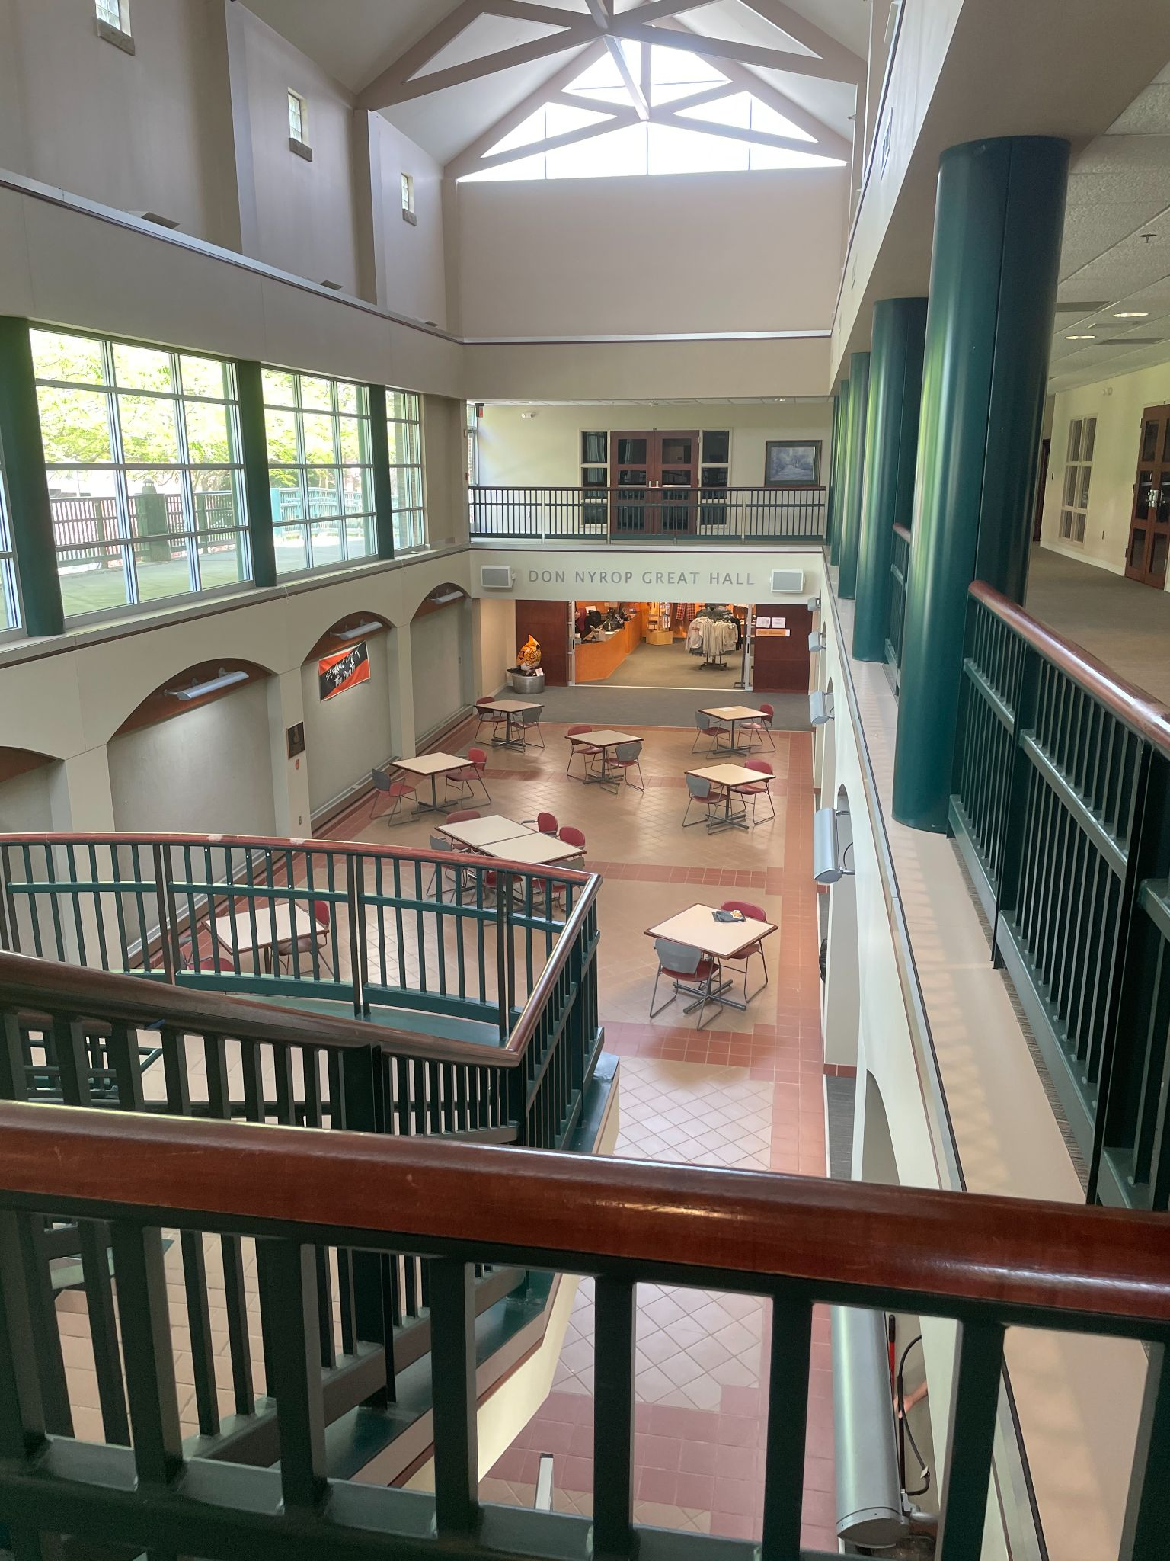
Breakout sessions will be using rooms on the upper level, so conference attendees will be using the upper walkway. Vendors may use space in either the lower level or on the upper level concourse.

Additional opportunity for sponsor exposure - Lunchtime Themed Room Experiences!
This year attendees will eat in the conference rooms found in Perry Campus Center. To make the lunch more interesting, we are proposing that each room have a lunchtime theme. For instance, a space themed room might include:
- Dimmed lights and a constellation projector
- Star charts on tables participants use to find the projected constellations
- Stories told from a book you sell about the stars
- Show a short video clip about how stars are born from a movie you sell

NATS is looking for proposals for themed lunches. While products and services may be showcased, this opportunity should not be thought of as a regular sales pitch but more of an experience for lunch goers that showcases products teachers might use in their classrooms. Any level of sponsor may apply for the themed room. Proposals will be selected by a panel of Nebraska teachers based on interest and uniqueness. Space is extremely limited.

Please complete the form below and return by August 1 for consideration by the NATS board.
Contact Scott King 307-286-5590, natsboard14@gmail.com for questions about this opportunity.

Themed Lunch Proposal

Sponsor Name:
Contact Name & email
Lunch Theme:
Explanation of themed activity/room components:
Room Requirements (ex: projector)
Any additional incentives we should advertise to attendees so they choose your lunch space?
Additional Information we need to know or questions you have?

Deadline for application: August 1st
Notification date: September 1st

Please email the form above to natsboard14@gmail.com for consideration.

