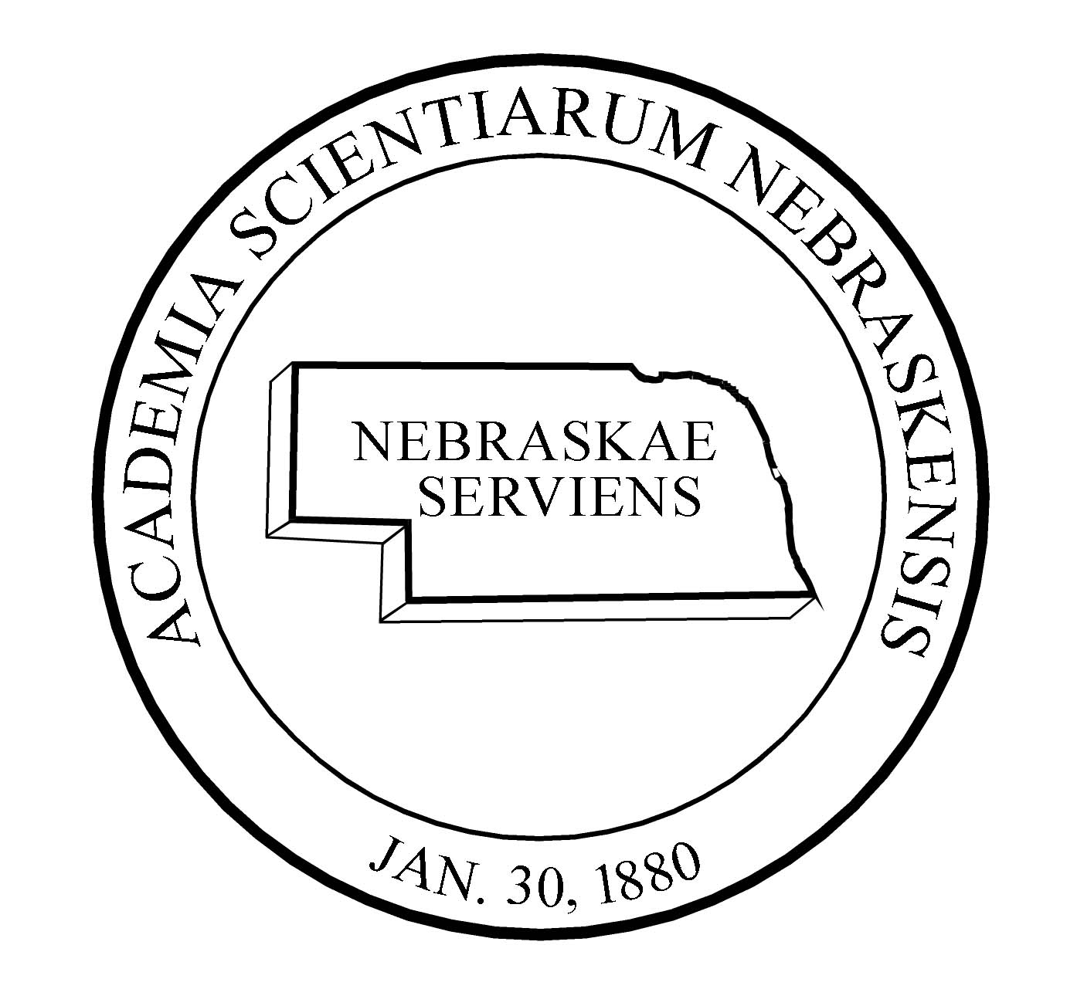NEBRASKA ACADEMY OF SCIENCES

SCHOLARSHIP APPLICATION SUMMARY

Scholarships sponsored by the Nebraska Academy of Sciences, Inc. require the completion of this Application Summary. In addition, scholarship applications require some written information, usually in the form of an essay referring to the particular scholarship –each is somewhat different in its requirements. Supporting information is also necessary, such as a list of the applicant’s activities and related accomplishments, testimonial letters from 2-3 supervisors or teachers, transcripts, etc. Please refer to the scholarship description for specific requirements. Typed material is preferred but clear handwriting is acceptable.

Applicant’s name ___________________________________
Applicant’s address ___________________________________
___________________________________

Email address ___________________________________

School name ___________________________________
School address ___________________________________
___________________________________

Teacher’s name ___________________________________
Parent(s) or Guardian(s) ___________________________________

Student Contact Phone ___________________________________
Scholarship name ___________________________________

Essay or research title ___________________________________

This form may be duplicated as necessary.

The postmark deadline for all high school scholarships is March 1. All materials should be sent to:
NEBRASKA ACADEMY OF SCIENCES, INC.
SCHOLARSHIP APPLICATION
P.O. BOX 880339
LINCOLN, NE 68588-0339
402/472-2644
Email documents accepted at <nebacad@unl.edu>

Application checklist: See scholarship listing for specifics
General checklist: _____ Application cover page
_____ Essay specific to the scholarship you are applying for
_____ Two Teacher recommendations
_____ High School Transcript
_____ Scholastic and or community achievements
_____ Evidence of acceptance at a Nebraska college or university

