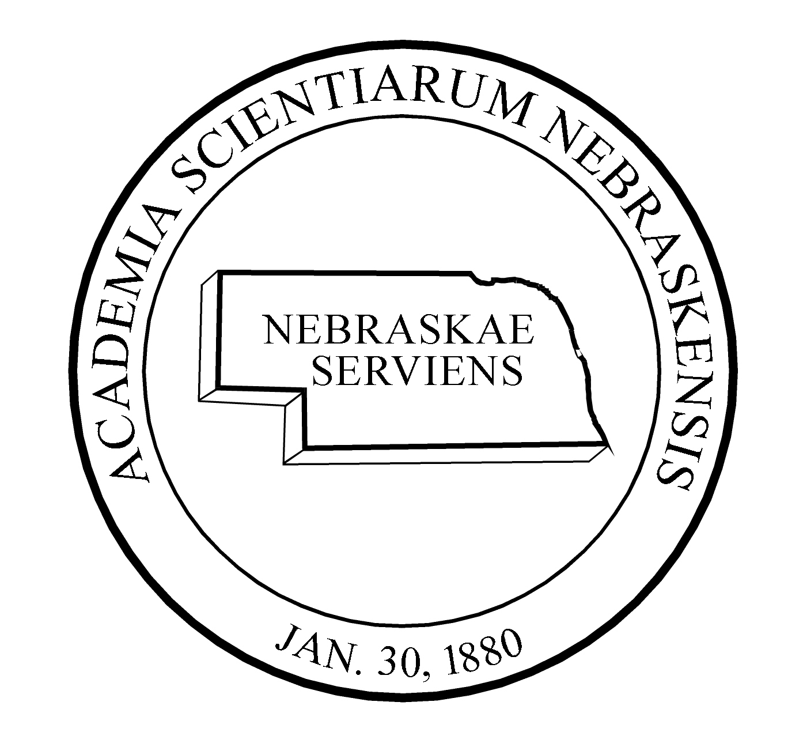

2021-22 PROGRAM COMMITTEE
NEBRASKA ACADEMYOF SCIENCES, INC.

Sections Chairperson(s)_____________________________________

MEETING PROGRAM CHAIRPERSON TBD

AERONAUTICS & SPACE SCIENCE Scott Tarry, starry@unomaha.edu
Michaela Lucas, mlucas@unomaha.edu
University of Nebraska Omaha

ANTHROPOLOGY Taylor Livingston, tlivingston3@unl.edu
University of Nebraska–Lincoln

APPLIED SCIENCE & TECHNOLOGY Mary Ettel, maettel1@wsc.edu
Wayne State College

BIOLOGICAL & MEDICAL SCIENCES Annemarie Shibata, annemarieshibata@creighton.edu
Creighton University

COLLEGIATE - BIOLOGY Therese McGinn, tmcginn@nebrwesleyan.edu
Nebraska Wesleyan University

COLLEGIATE CHEMISTRY & PHYSICS Nathanael Fackler, nfackler@nebrwesleyan.edu
Nebraska Wesleyan University

EARTH SCIENCES Irina Filina, Ifilina2@unl.edu
University of Nebraska–Lincoln

ENVIRONMENTAL SCIENCES Mark Hammer, mahamme1@wsc.edu
Wayne State College

GENERAL CHEMISTRY Joshua Darr, jdarr@unomaha.edu
University of Nebraska at Omaha

GENERAL PHYSICS Adam Davis, aadavis1@wsc.edu
Wayne State College

HISTORY & PHILOSOPHY of SCIENCE Dan Sitzman, Daniel.sitzman@ops.org
Omaha Public Schools,

TEACHING OF SCIENCE & MATHEMATICS TBD

Affiliated Societies:

NEBRASKA JUNIOR ACADEMY Randall Lienemann, rlienema@gmail.com
OF SCIENCES, REP.

NEBRASKA ASSOCIATION OF TBD
TEACHERS of SCIENCE, REP.

Assisted by:

EXECUTIVE SECRETARY Betty Talley, nebacad@unl.edu
Nebraska Academy of Sciences

TECHNICAL PROGRAM & WEB EDITORS Lindsay Augustyn, laugustyn2@unl.edu
Stephanie Vendetti, stephanie.vendetti@unl.edu
Center for Science Math and Computer Education
University of Nebraska-Lincoln

