ISS Separation Challenge - Water Filtration System
Background
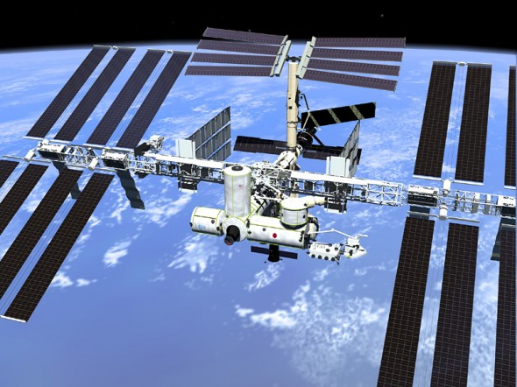
The Earth provides us with a natural support system, the air we need to breathe, the water to drink, and temperatures we can survive in. When exploring space we leave this natural support system and need to create an artificial support system. The Environmental Control and Life Support System (ECLSS) helps provide this system on the International Space Station. The purpose of the ECLSS includes:
- Provides oxygen for metabolic consumption.
- Provides potable water for consumption, food preparation, and hygiene uses.
- Removes carbon dioxide from the cabin air.
- Filters particulates and microorganisms from cabin air.
- Removes volatile organic trace gases from the cabin air.
- Monitors and controls cabin air partial pressures of nitrogen, oxygen, carbon dioxide, methane, hydrogen, and water vapor.
- Maintains total cabin pressure.
- Maintains cabin temperature and humidity levels.
- Distributes air between connected modules.

The Water Recovery System (WRS)
The Water Recovery System is an important part of the ECLSS. It provides clean water by reclaiming wastewater from crew member urine, hand wash, cabin humidity, condensates, and extravehicular activity wastes. The water must meet the highest standards as it will be used to support the crew about the ISS. The system reduces the amount of water that would need to be launched from Earth to support six crew members.
- The WRS consists of two main parts, the Urine Processor Assembly (UPA) and the Water Processor Assembly (WPA). Water is recovered from urine using a low-pressure vacuum distillation process. The distillation assembly rotates, compensating for the microgravity environment in which it functions. This false gravity functions to separate gases and solids. Water obtained from the Urine Processor Assembly is combined with other waste water in the Water Processor Assembly. The WPA removes gas and solid materials like lint and hair from the water before it goes through a long series of filtration beds for further purification. Any remaining organic contaminants are removed by a high-temperature catalytic reactor assembly. The purity of the water is checked by electrical conductivity sensors as the conductivity of water is increased by the presence of typical contaminants. If water passes the test it is sent to a storage tank for future crew use, unsatisfactory water is sent through the purification process, again.

The water recovered and purified by the WRS on the ISS has a pH of 4.5 to 7. This lower pH is a result of the addition of iodine to the filtered water.

Materials
For each team:

- Cheesecloth (10cm X 10cm)
- Utility Knives and scissors
- Cotton Balls (10-15)
- Coffee Filters (2)
- Activated Carbon (charcoal) (200g)
- Sand (200g)
- Uncooked Macaroni (100g)
- Rice (100g)

Guidelines:
- You must design a water filtration system to make the purest water possible, the most pure water possible, and stay under the designated budget. You will test the purity of the water by observing color, smell, conductivity, and pH. You will have a budget of 50 million dollars to build your purification system, and be given 200 mL of wastewater to clean.
- The materials that you will have at your disposal and the cost of each of the items.

Budget $50 million
Two plastic bottles (normal water bottles) | Free
Cotton Balls | 1 million ea.
Coffee Filters | 5 million ea.
Activated Carbon (200 g) | 15 million
Macaroni (100 g) | 10 million
Sand (200 g) | 10 million
Cheese Cloth | 5 million ea.
Rice (100 g) | - million
Other (to be approved and priced by teacher) | TBD

- Choose your team and brainstorm some ideas for your system. Sketch a design of your device, and obtain your materials. YOU TOUCH IT, YOU BUY IT…Remember you are working under a budget.
- Build your filtration device. Measure the volume, color, smell, pH, and conductivity of the unfiltered water and record it on your data sheet.
- After the device is constructed, filter your wastewater. Your goal is to get the highest efficiency from your device and to get the cleanest water, so you will need to take more data on volume and various purity tests.

Wastewater Filtration Design
Team Members: _____________________________________________________________________________
Design:
Sketch your filtration device design. Label each section and describe what each material will do. Explain the reason for the order of the materials in the device. Label about how much of each material was used, and the cost of each.
Sketch
Explanation/Cost
______________________________________________________________________________________________________________________________________________________________________________________________________________________________________________________________________________________________________________________________________________________________________________________________________________________________________________________________________________________________________________________________________________________________________

Results:
Wastewater | Filtered Water
Volume | Volume | Percent Recovered
pH | pH
Conductivity | Conductivity
Color | Color
Smell | Smell

Multiple Filtrations:

Conclusions:
Describe your results. Were you successful? How might you redesign?

